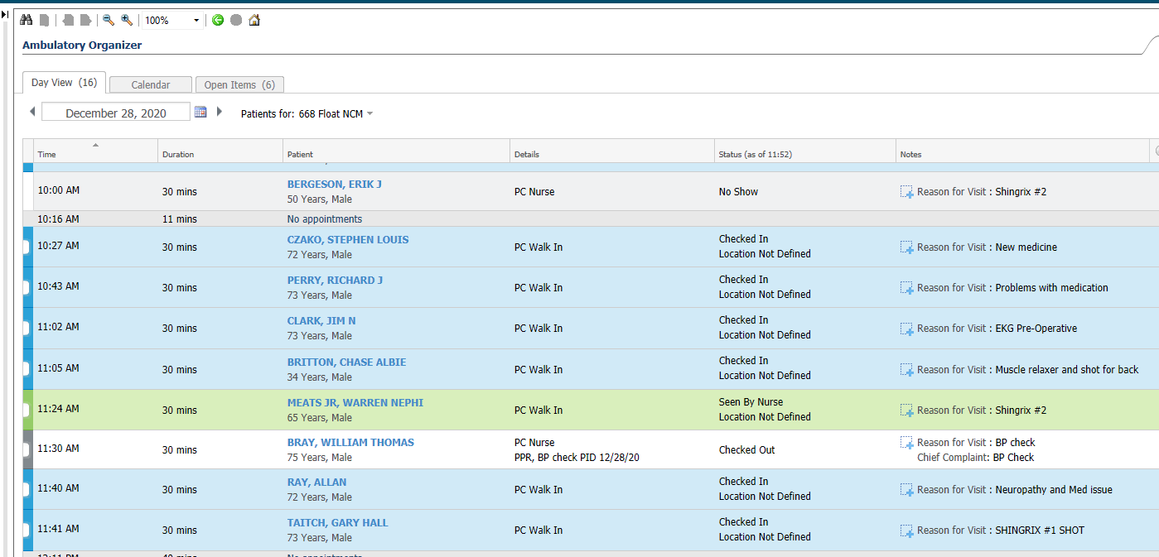



Open Ambulatory Organizer – Open Veteran’s Chart by clicking on the blue hyperlink of their name.

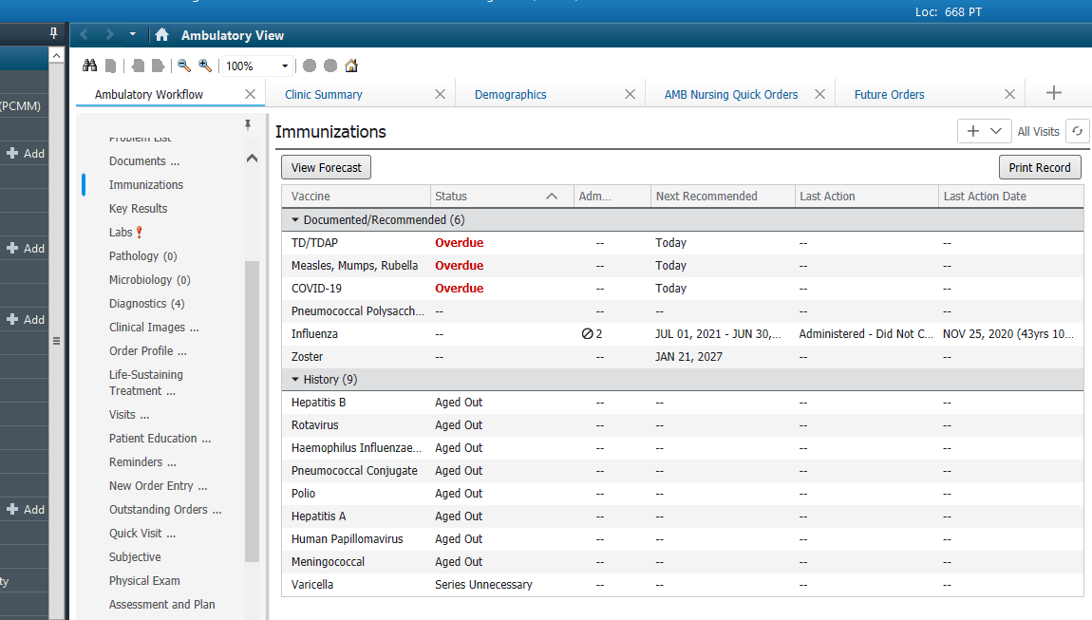

Be sure you are working in your ambulatory organizer. Go to Immunization component.

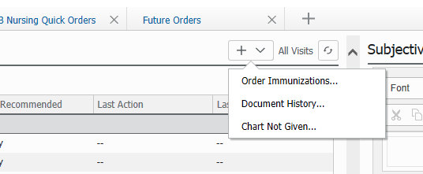



Click the drop down to order the immunization.

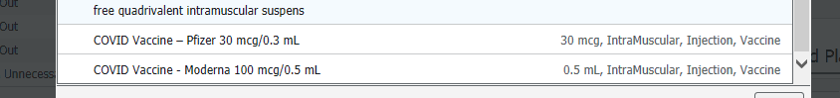

Select the correct order sentence.

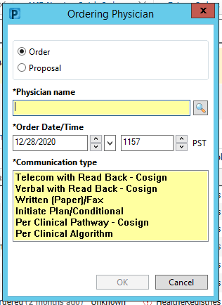

Select order type and ordering provider.



Go to the orders for signature cart in the upper right hand corner. Click on the green 1.

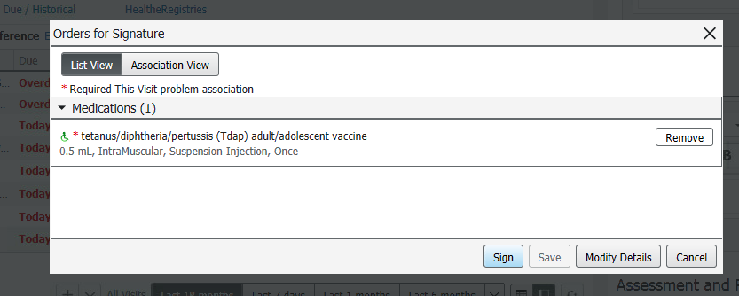

Choose sign.

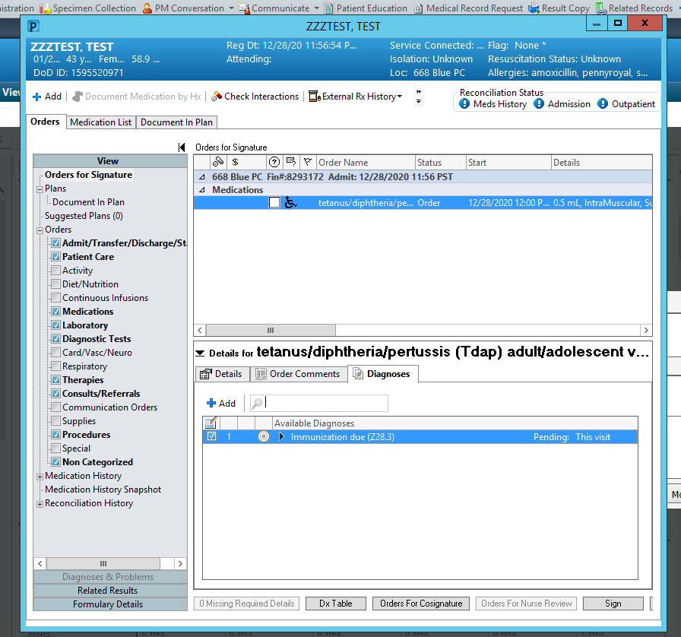

Select immunization due for appropriate diagnosis. Then sign the order.

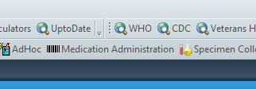



Once order is co-signed by provider – go to Medication Administration Wizzard in the top grey toolbar.

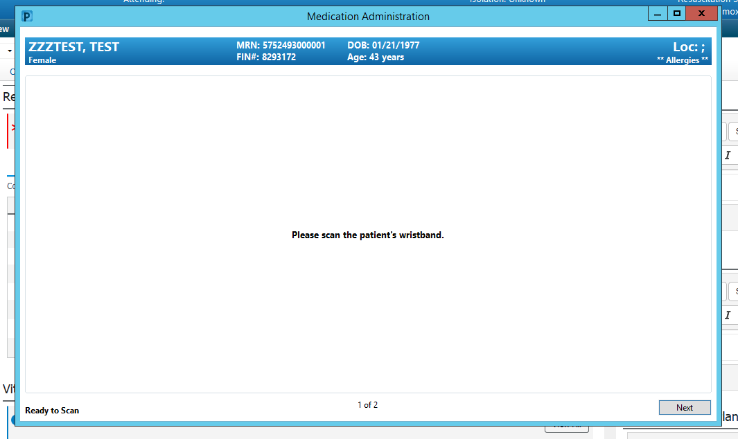

Scan patient’s wrist band. Or hit next to over-ride.

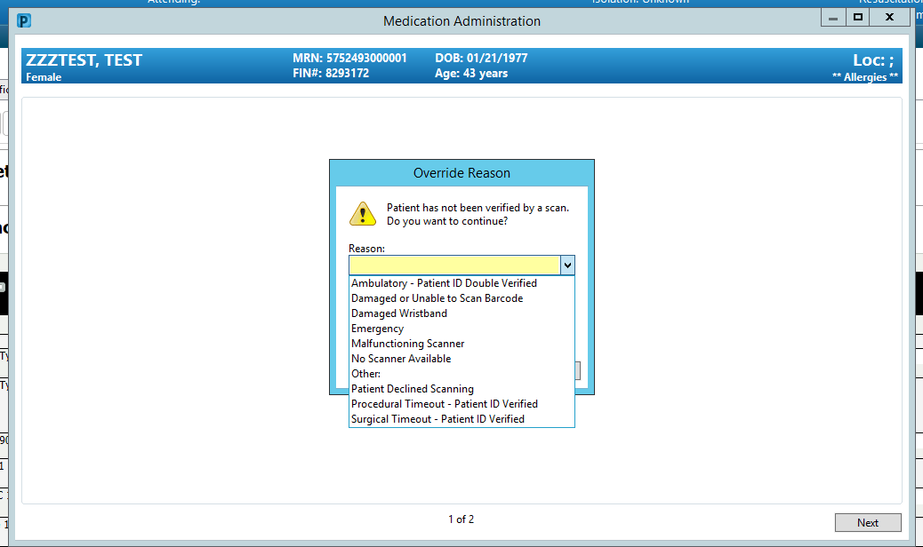



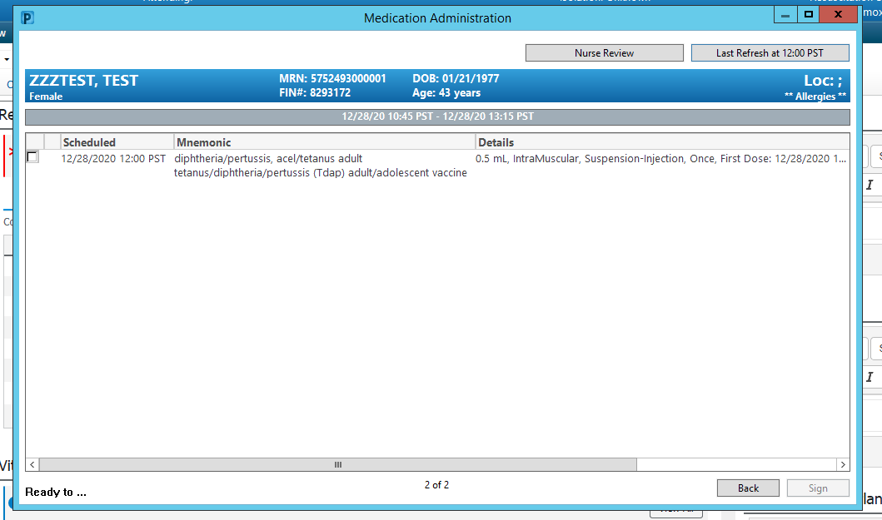

Scan medication barcode.

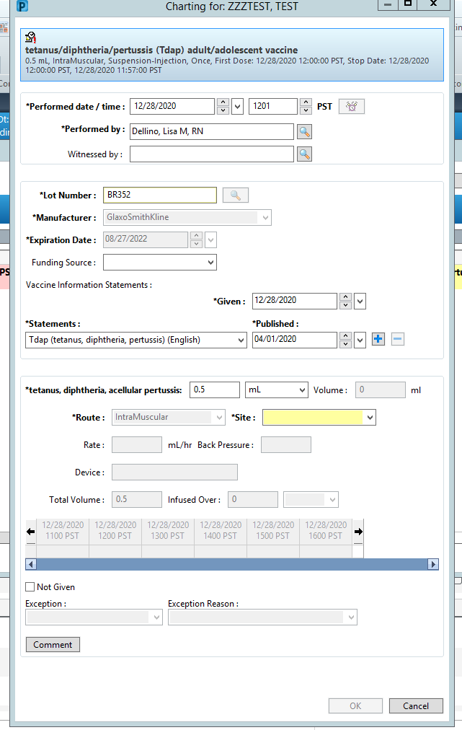



Verify lot and expiration. Identify correct site. Then click OK.

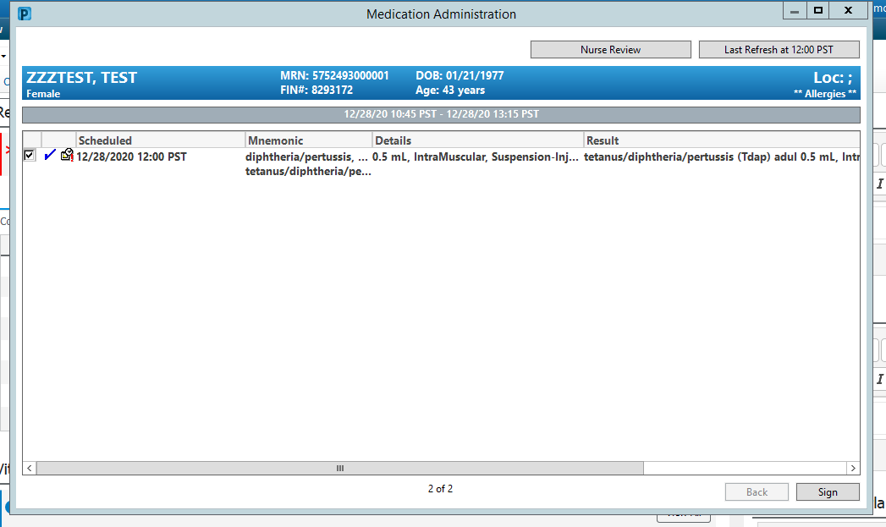



Click Sign.

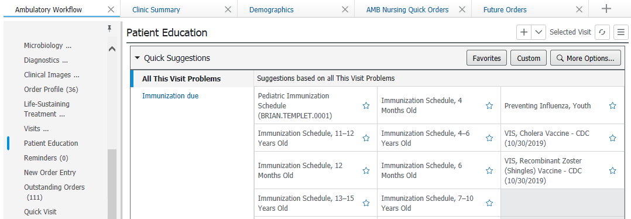



Go to Patient Education component in your Ambulatory workflow on the left. Click Custom.

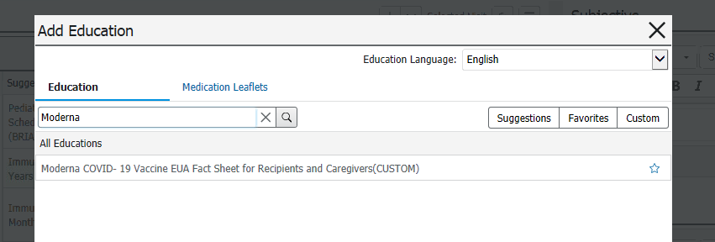

Search for Moderna.

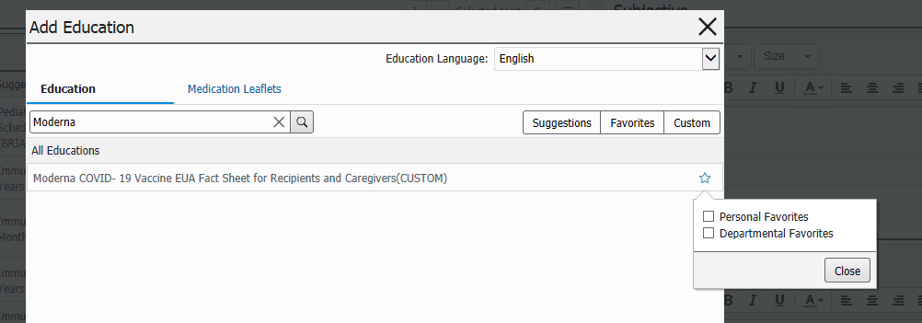



Click the stat and add to personal favorites. Then click on the name to add it to the Veteran’s education for this visit. This is the EUA factsheet. It will automatically go to the Veteran’s portal if they are enrolled. If not, you can print it with their visit instructions.

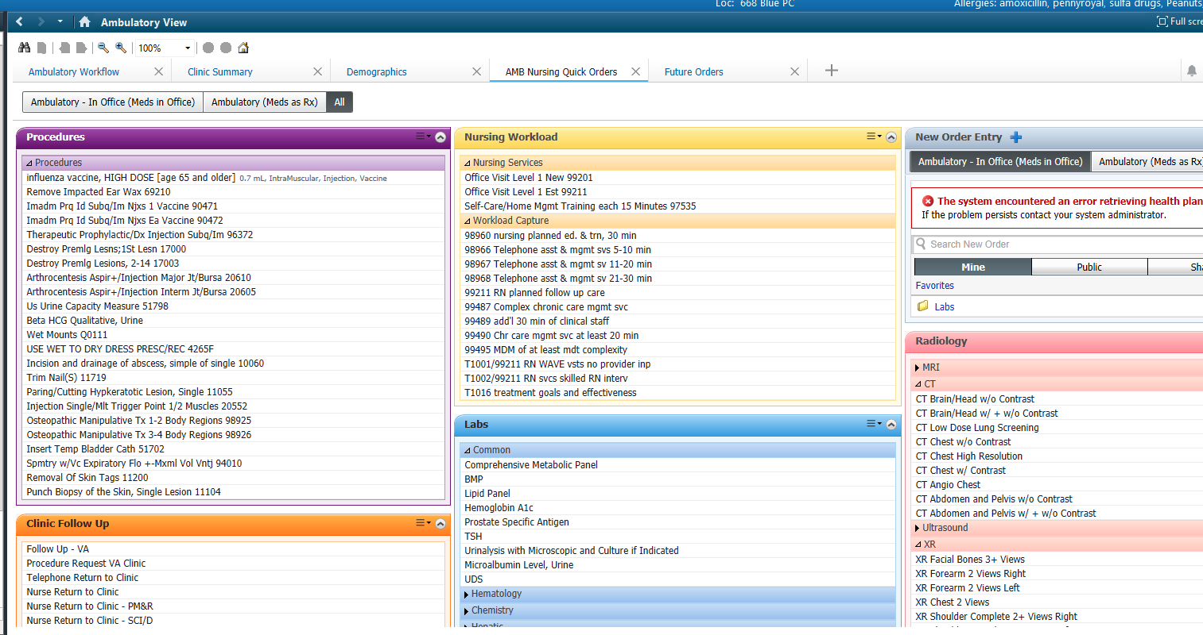



Navigate to Nursing Quick Orders mPage. Select workload 99211 and Follow up – VA.

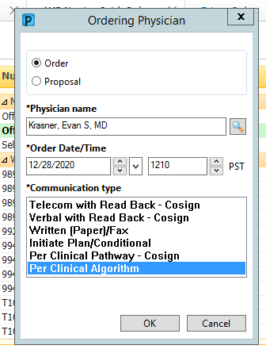

Select order (under appropriate provider) per Clinical Algorithm.

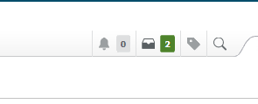



Click on Orders for Signature cart.

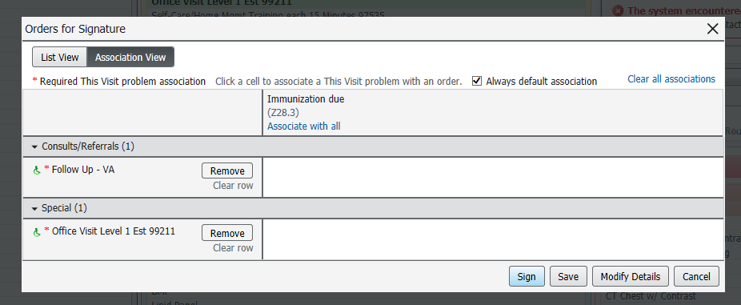



Associate diagnosis and then click Modify Details.

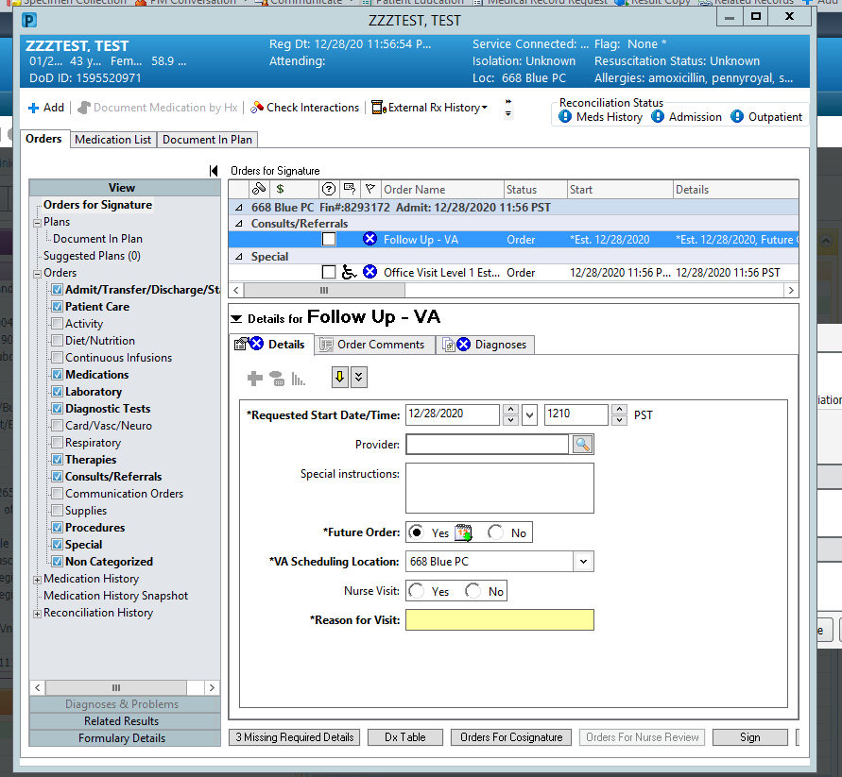

Click on Follow up – VA order to modify.

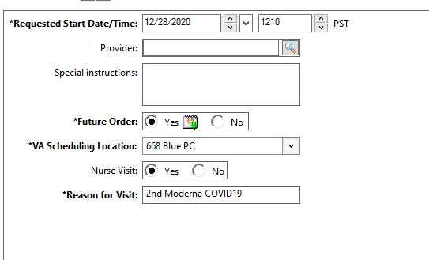

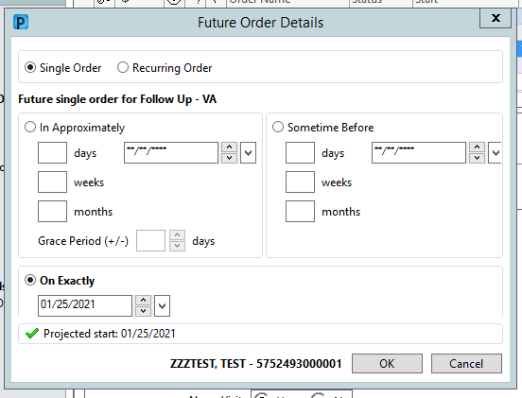

Click on future order – YES and select date for follow up visit.

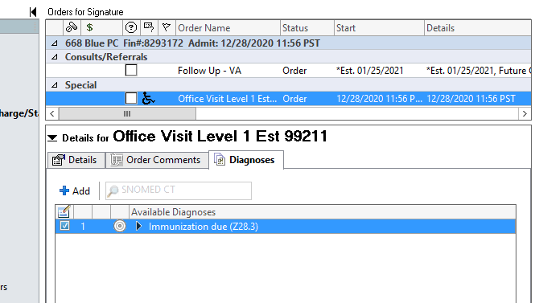

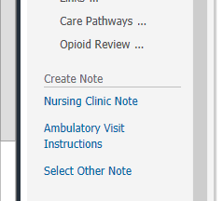



Click on Ambulatory Visit Instructions.

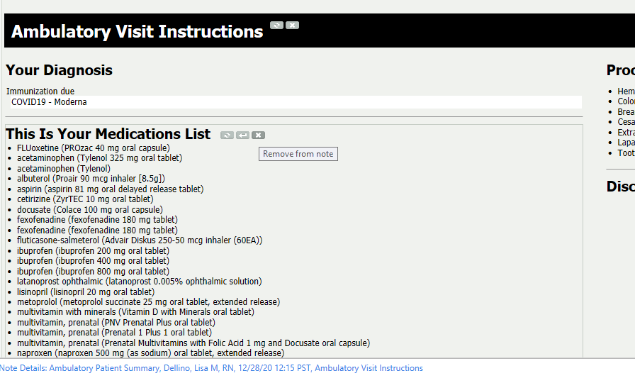



Click the drop arrow to add free text or the x to delete unneeded sections.

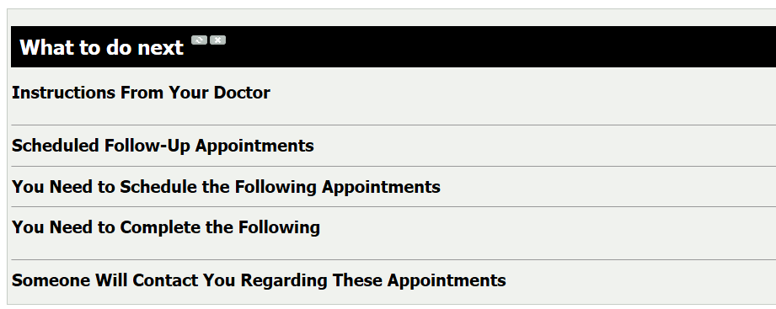

The follow up visit scheduled will populate into Scheduled Follow-Up Appointments.

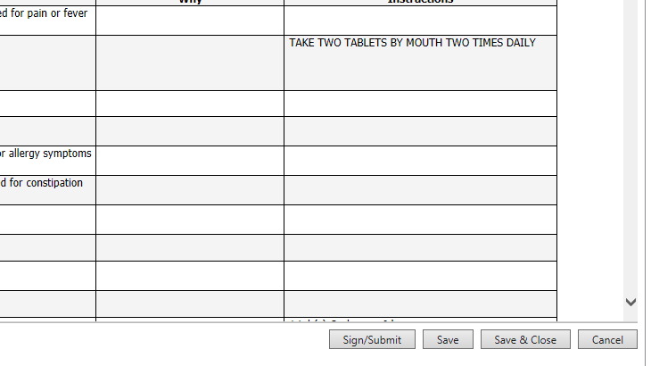

Click Sign/Submit.

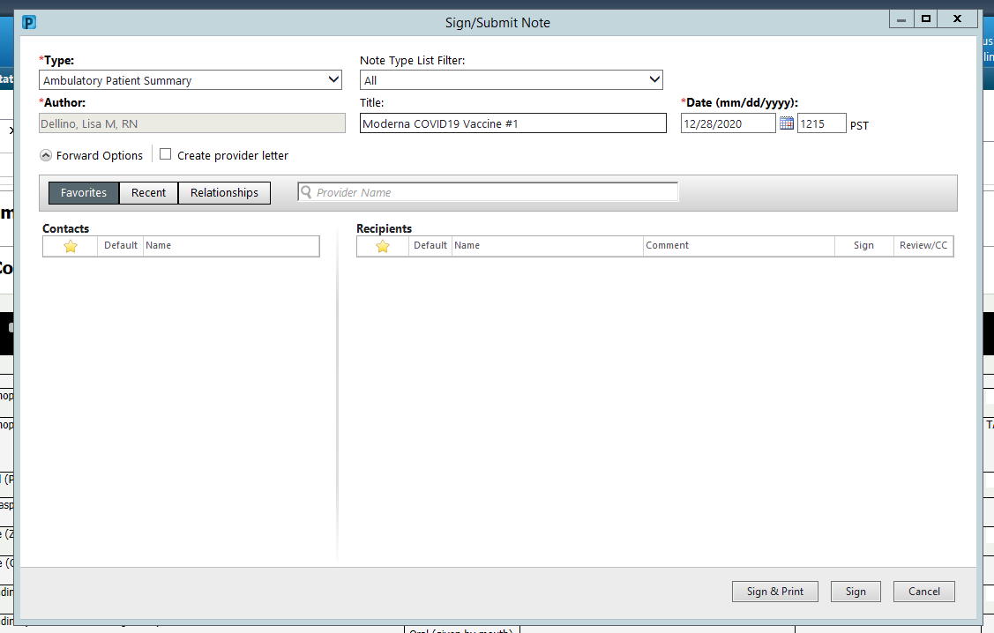



Be sure to update Title to relevant information. If the Veteran prefers a written copy – click Sign & Print. If the Veteran has access to the Portal, the Ambulatory Patient Summary will be available there for review.

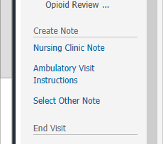



To complete your note – go to the bottom of the components of the Ambulatory Workflow on the left. Click Nursing Clinic Note.

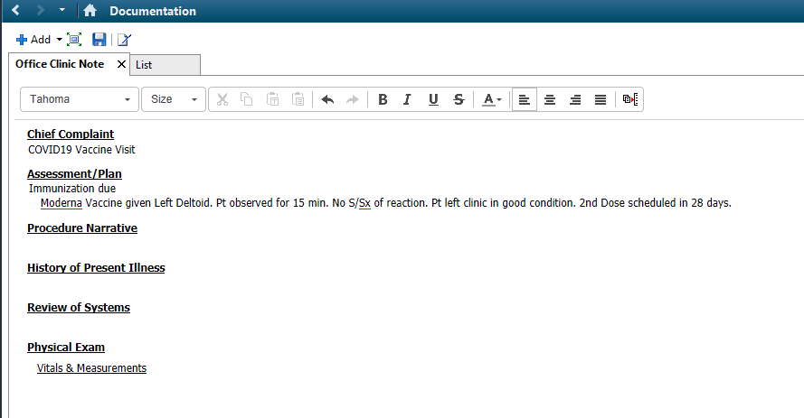

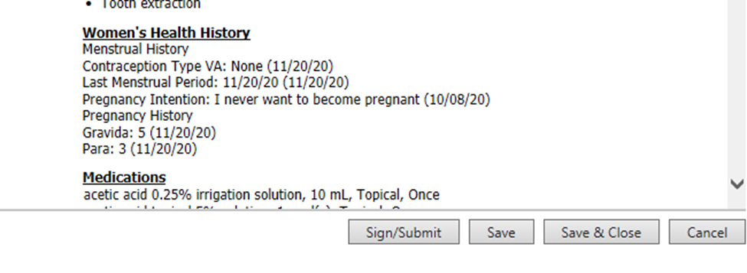

Fill in any needed information. You may delete any unneeded sections of the note. Empty/Blank sections will autodelete on signing. Then select Sign/Submit.

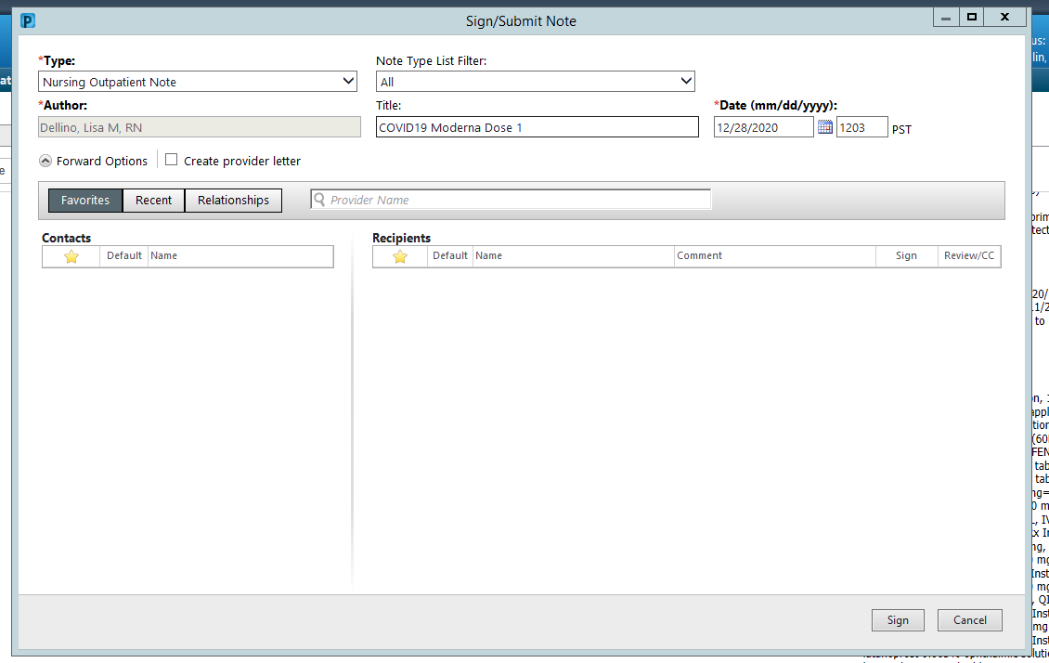



Be sure to update Title to relevant title. Then Sign.